**LAB 6**

**OBJECTIVE**

To modify the page content using JavaScript.

**DESCRIPTION**

JavaScript (JS) is a lightweight, interpreted, or just-in-time compiled programming language with first-class functions. While it is most well-known as the scripting language for Web pages, many non-browser environments also use it, such as Node.js, Apache CouchDB and Adobe Acrobat. JavaScript is a prototype-based, multi-paradigm, single-threaded, dynamic language, supporting object-oriented, imperative, and declarative (e.g. functional programming) styles.

It is a full-fledged dynamic programming language that, when applied to an HTML document, can provide dynamic interactivity on websites. Like CSS, Javascript code should be placed in its own file. Javascript files have a .js extension. To run the .js file in an HTML page the javascript file should be referenced using a <script> HTML tag.

JavaScript can change the content of an HTML page, modify its style, hide or show HTML elements and even more.

**HTML**

<!DOCTYPE html>

<html>

<head>

<title>Random Numbers</title>

<link rel="stylesheet" type="text/css" href="css/random.css">

<script type="text/javascript" src="js/random.js"></script>

</head>

<body>

<div id="content">

<table cellspacing=10>

<tr>

<td>1</td>

<td>2</td>

<td>3</td>

<td>4</td>

<td>5</td>

</tr>

</table><br>

<div id="button">

<button>Draw Numbers</button>

</div>

</div>

</body>

</html>

**CSS**

table tr td {

padding: 20px 25px;

background-color: red;

border-radius: 10px;

font-size: 30px;

}

#content {

width: 40%;

display: flex;

flex-direction: column;

}

#button {

text-align: center;

}

**JavaScript**

function drawNumbers()

{

var table = document.getElementsByTagName('table');

var tds = table[0].getElementsByTagName('td');

for(var i = 0; i<tds.length; i++)

{

var r = Math.ceil(Math.random()*20);

tds[i].innerHTML = r;

}

}

function myLoad()

{

var button = document.getElementsByTagName("button");

button[0].addEventListener("click",drawNumbers);

}

document.addEventListener("DOMContentLoaded", myLoad);

**OUTPUT**

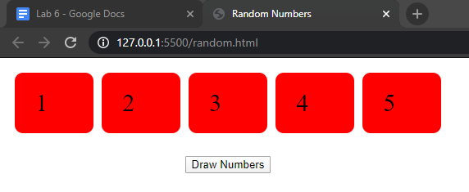

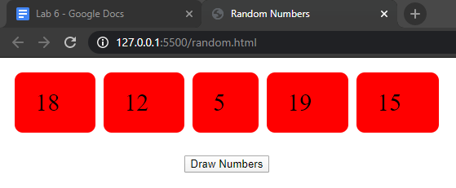

**HTML**

<!DOCTYPE html>

<html>

<head>

<title>Random Numbers</title>

<link rel="stylesheet" type="text/css" href="css/random2.css">

<script type="text/javascript" src="js/random2.js"></script>

</head>

<body>

<button>Draw Numbers</button><br>

</body>

</html>

**CSS**

table tr td {

padding: 20px 25px;

background-color: red;

border-radius: 10px;

font-size: 30px;

}

**JavaScript**

function drawNumbers()

{

var table=document.getElementsByTagName('table');

if (table.length>0)

{

table[0].parentNode.removeChild(table[0]);

}

var table = document.createElement('table');

var tr = document.createElement('tr');

table.appendChild(tr);

for (var i=0;i<5; i++)

{

var r= Math.ceil(Math.random()*20);

var td=document.createElement('td');

var textNode = document.createTextNode(r);

td.appendChild (textNode);

tr.appendChild(td);

}

document.getElementsByTagName('body')[0].appendChild(table);

}

function myLoad()

{

var button = document.getElementsByTagName("button");

button[0].addEventListener("click",drawNumbers);

}

document.addEventListener("DOMContentLoaded", myLoad);

**OUTPUT**

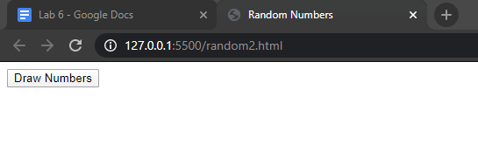

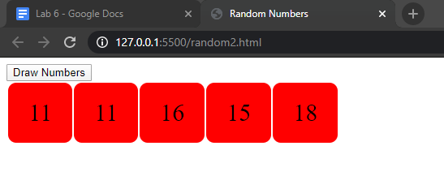

**SUMMARY**

In this lab, we first created an HTML document and then modified the content of the page using Javascript. Javascript syntax was a bit complex at first to learn but it was fun learning.

**COMMENT**